**Sales Forecasting Python**

*By Ong Qiao Hui on 12 January 2024.*

# Dataset [Data.csv]

Daily historical data from July 2021 to January 2024.

* sales_date– date in format dd/mm/yyyy
* sales_amount– total sales for each day

## **Linear Regression**

**Goal: Get the predictions for monthly sales in future.**

1. Import all the library that would be used.

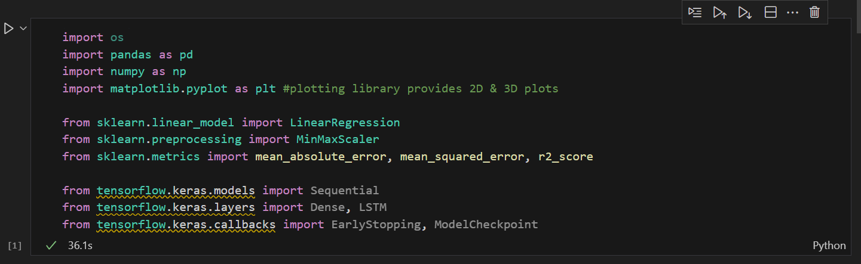

1. Read csv file and display the first 10 rows.

1. Check info from the dataset to know that does it contain null value and how much data is contained in the dataset.

1. Converting data type of date from Object to DateTime.

1. Converting Date to a Month period, then sum the number of items in each month.

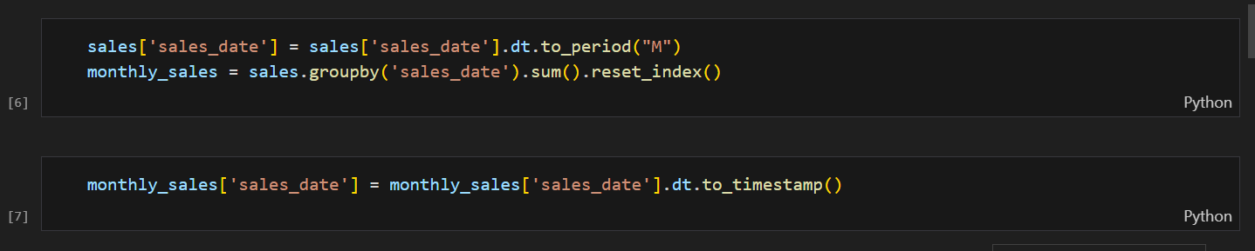

1. Visualization for the data.

1. Call the difference on the sales columns to make the sales data stationary. (Difference between last month)

1. Dropping off sales_date and sales_amount because now only need Stationary data.



1. Prepare Supervised Data (Previous 12 months sales will be the input features, Next 12 months sales will be the output)

1. Split data into Train & Test data.

1. Make prediction data frame to merge the predicted sales prices of all trained algorithms.

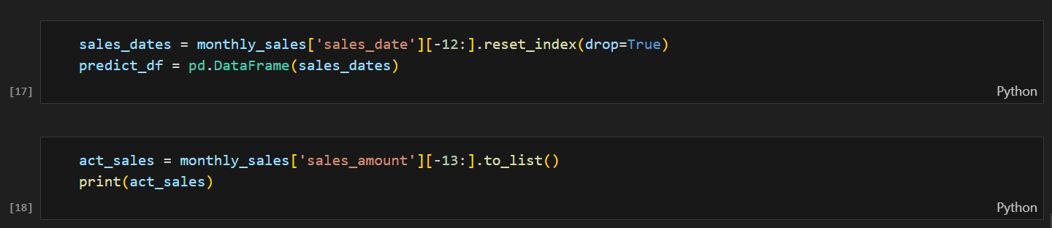

1. Create Linear Regression Model and Predict Output.

1. Visualization of the prediction against the actual sales.

1. Get the predicted sales for every month.

## **Random Forrest**

**Goal: Get the predictions for monthly sales in future.**

1. Import libraries.

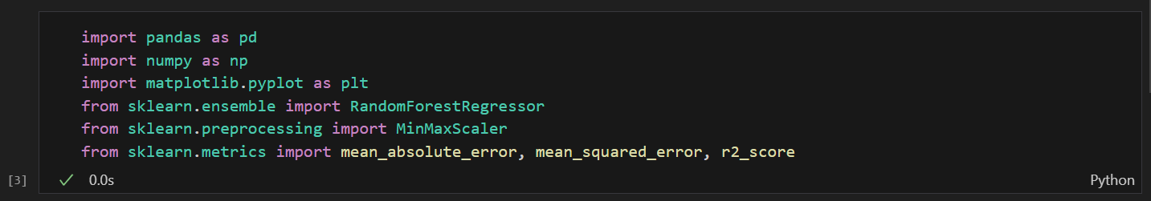

1. Read dataset (.csv)



1. Converting Date to a Month period, then sum the number of items in each month.

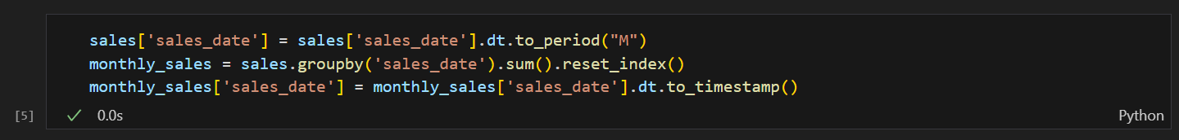

1. Visualize Monthly Customer Sales

1. Call the difference on the sales columns to make the sales data stationary. (Difference between last month)



1. Dropping off sales_date and sales_amount because now only need Stationary data.



1. Prepare Supervised Data (Previous 12 months sales will be the input features, Next 12 months sales will be the output)

1. Split data into Train and Test data

1. Create Random Forrest Regressor Model

1. Visualization of the prediction against the actual sales.

## **XGBoost**

**Goal: Get the predictions for monthly sales in future.**

1. Import Libraries and read dataset.

1. Converting date from Object to dateTime

1. Converting Date to a Month period, then sum the number of items in each month

1. A screen shot of a graph

   Description automatically generatedVisualization
2. Call the difference on the sales columns to make the sales data stationary (Difference between last month)

1. Dropping off sales_date and sales_amount because now only need Stationary data



1. Prepare Supervised Data (Previous 12 months sales will be the input features, Next 12 months sales will be the output)

1. Split data into Test and Train data

1. Create XGBRegressor Model

1. Visualization of the prediction against the actual sales.

# **Dataset [Sales_datasetA.csv]**

Daily historical data from June 2020 to December 2023.

Columns will be used:

* Order_Date – date in format yyyy-mm-dd
* Order_TotalSales - total sales for each day

## **Random Forrest**

**Goal: Get the predictions for daily sales in future.**

1. Import libraries.

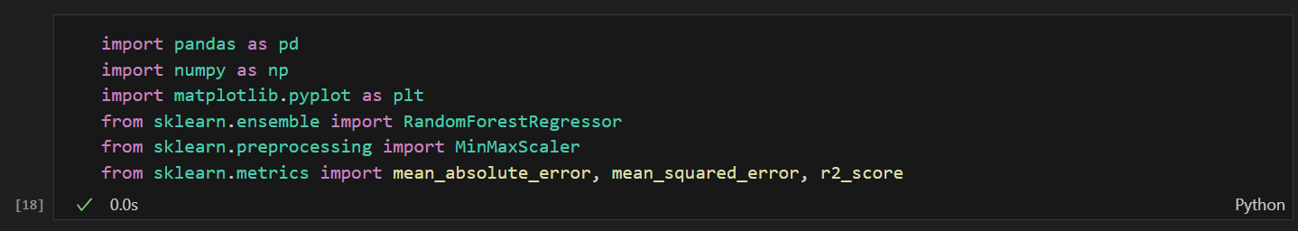

1. Read dataset.

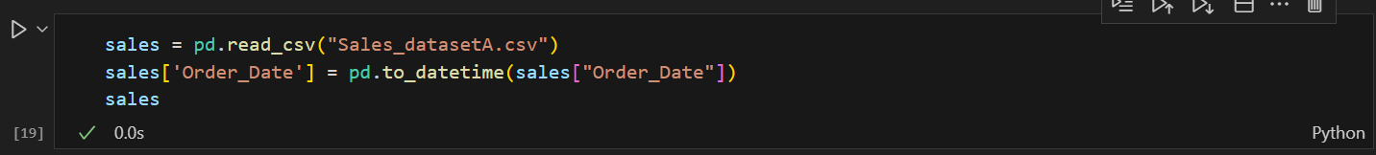

1. Converting Date to a Day period, then sum the number of items in each day.

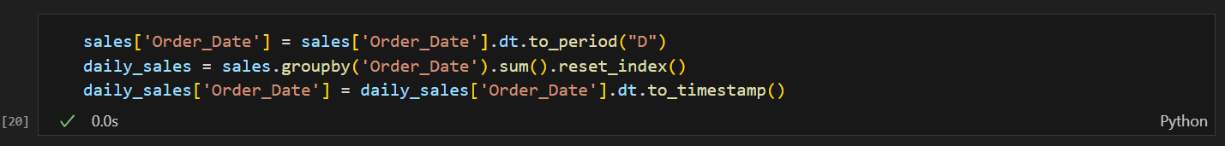

1. A screen shot of a graph

   Description automatically generatedVisualization
2. Call the difference on the sales columns to make the sales data stationary and drop the unuse columns

1. Prepare Supervised Data

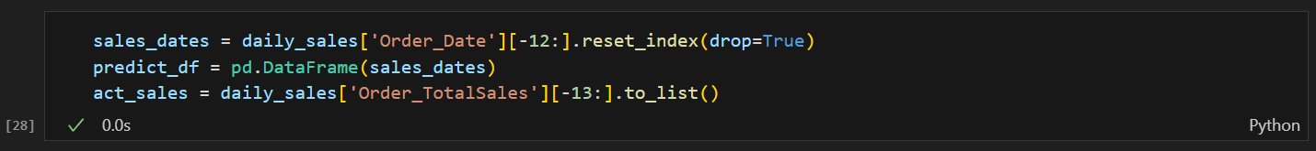

1. Create Random Forrest Regressor Model

1. Visualization of the prediction against the actual sales.

1. Show the predicted sales amount for each day.

## **Time Series (XGBoost)**

**Goal: Get the predictions for daily sales in future.**

1. Import libraries.

1. Read dataset and drop the unuse columns.

1. Visualization

1. Split data into Test and Train data

1. Create time series for the data

1. Add features and target to check which features is important.

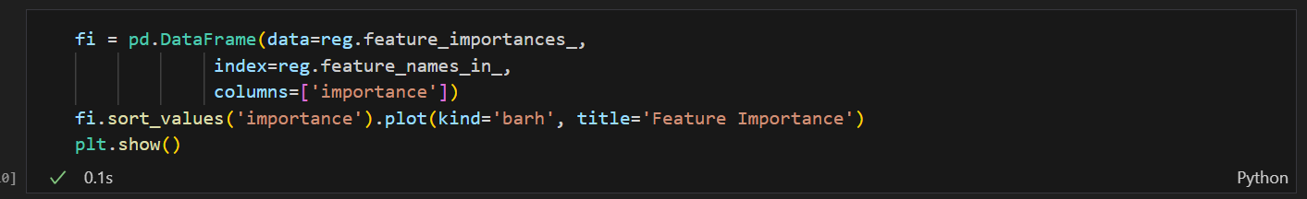

1. Prediction

1. Predict sales for 1 week

